**STREET TECH**

**LEADER:**

Serafica Jr., Renato I.

**MEMBERS**

Barrozo, Vicky A.

Compendio, Kimberly Joy C.

Lacaba, Raymund F.

### 

### **Executive Summary**

Street Tech falls under general partnership and takes on the mobile industry. In 2027 Street Tech will be launching an online shop business that offers different brands of smartphones.

With restrictions on face to face clinical consultations in the COVID-19 pandemic and the challenges faced by health care systems in delivering patient care, alternative information technologies like telemedicine and smartphones are playing a key role.

Street Tech plans to launch an online mobile shop where people can buy different brands of smartphones through the website. Less exposure to people and that means less risks of contracting COVID-19 compared to going into a store where there are other people.

Street Tech's mission is to offer its customers the highest quality cell phone products and services. Street Tech focuses on personalized service to customers by offering convenience and rapid service.

Objectives:

Street tech's target in the first three months is to become known to people, and social media. To establish good relationships with people and provide good and convenient service.

### **Identifying Opportunities and Generating Ideas**

Street Tech is an online Mobile shop that sells different brands of smartphones. Our group came up with this idea because it will help us to use our knowledge and skills in web development.

With the booming online business and rapid growth of social media users, we aim to provide hassle-free transactions with our customers and will operate 24/7 and the company will be limited to online transactions. As a start-up business, we have limited resources and we want to focus on interaction with customers through digital and reduce the needs of the workforce and choose the business location.

Both businesses and customers will benefit as we aim to go digital and reduce the transaction processing system. This will allow the business to expand and gain potential customers. It allows the customer to shop at any time they want, and learn more about the product and services we offer.

### **Choosing a Form of Business**

Street Tech falls under General Partnership. By definition, general partnership refers to “a form of business organization in which two or more people pool their skills, abilities, and resources to run a business.”

As a business that is only starting out, we think it best for the business’ survival and success to not only rely on a single person. This also means that the skills and abilities of more than one individual are available to be utilized by the business. On the other hand, it can be seen that the products offered by the business are limited to what the business has. When the company has established a solid foothold, it can expand and, as a result, we can hire more staff to assist with operations. At that point, this barrier can be overcome.

When it comes to funds, raising funds can be done by multiple people simultaneously. People working for the shop can respond to business losses as well, potentially reducing the negative impact that comes with these losses.

Although this can be seen as a negative thing, the fact that decision-making among the other partners is to be shared can also mean that there would be more people involved in making the decisions. Therefore, more ideas can be brought to the table and the people within the group can look at things in different ways and perspectives that a single person might not be able to see.

### **Business Models**

Our business falls under the B2C (business to consumers) business model, where we directly sell our products to our customers. Since our business operates online, there will be no middle man and the decision making will be short. With this business model, we will spend less in terms of advertising, promotion, and a few issues with the ordering process.

In terms of order processing, our business will list the products and services offered along with the price. It allows customers to decide and select the product and service he wants to avail. Additional charges may apply for shipping fees and changes in price without prior notice, as the business will depend on the pricing strategy of the supply and demand.

### **Industry and Competitor Analysis**

Ecommerce industry has helped businesses (especially those with a narrow reach like small businesses) gain access to and establish a wider market presence by providing cheaper and more efficient distribution channels for their products or services. Ecommerce has changed the way people shop and consume products and services. More and more people are turning to their computers and smart devices to order goods, which can easily be delivered to their homes. New technology continues to make it easier for people to do their online shopping. People can connect with businesses through smartphones and other devices and by downloading apps to make purchases. The introduction of free shipping, which reduces costs for consumers, has also helped increase the popularity of the ecommerce industry.

The smartphone industry has been steadily developing and growing since 2008, both in market size and in number of models and vendors. Smartphone shipments worldwide are projected to add up to around 1.43 billion units in 2022. By the end of 2020, 78.05 percent of the world's population were smartphone users. **Direct competitors**

There are plenty of competitors going on today in the ecommerce industry like lazada, shopee, QSL wireless, Guanzon, Silicon Valley, QSL wireless and other online stores. Our goal is to create a recognizable brand that consumers will find trustworthy. It is also much easier to sell our products to existing customers as they are already familiar with our brand and our products. we will need to offer deals and promotions from time to time.

**Pricing**

Most cell phones are manufactured in the United States and other parts of the world, so it's not easy to determine what price to charge for a cell phone. However, we do not set prices that are far below what our competitors are offering, nor do we put ourselves at a loss.

**Business Product Benefits**

Using mobile phones in business can boost productivity, mobility, safety and morale of your workforce. Mobiles can help employees to:

* improve customer service
* remain in contact with the office, customers and suppliers
* increase mobility
* increase productivity
* work remotely (eg work from home or away from an office)

**List of Competitors in our Business**

**QSL wireless**- QSL's business has inevitably grown from a simple repair shop to a dealer of radio transceivers and other communication devices accredited by the NTC. QSL now carries a full line of products, including two-way radios, phone patches, repeaters, duplexers, wireless phones, fax machines, telephone sets, and pagers. To further diversify its offerings, QSL also provides services like antenna design and system design.

**Guanzon**- They create and uphold competition in the retail market for mobile phones. The Guanzon Group of Companies will always work to make life as comfortable as possible for every Filipino by offering the greatest and highest-quality goods and services.

**Silicon Valley**- Silicon Valley has expanded to a chain of retail stores focused on Gadgets such as smartphones, tablets, digital cameras, video recorders, computer sets, parts, and printing supplies were later introduced in their product lineup. Silicon Valley is also fast becoming a destination for all Mobile Devices. Silicon Valley is able to maintain its position of being one of the top IT Reseller in the country.

### 

### **SWOT Analysis**

**Overview**

In 2027, Our Street tech will be launching as an online mobile shop business. The business operates online and will start offering different brands of smartphones.

The shop also has a unique brand of smartphones. This SWOT analysis will assess the business’s current capabilities and identify the areas of opportunities for marketing its latest product offer.

**Strengths**

The current pricing of smartphones differs from its brand and model. This mobile business online is very known in the marketplace nowadays and maybe a positive alternative to traditional business. With the social media platform, clients can quickly find our business regardless of the time.

| **STRENGTHS** | **ACTION** |
| --- | --- |
| Affordable pricing. | Highlight this strength in every ad and post on online platforms, such as Facebook, Instagram, and the shop’s Website. |
| Wide variety of smartphone brands | Lists the smartphone brand and model on the website that is accessible. |
| The business operates online. | Protect Shop’s Online Reputation, Organize Web Assets. |

**Weaknesses**

Although smartphones have appealed to the target market, the business’s current strength. As a start-up business, it hardly attracts new customers and wins customers’ trust. Due to customer satisfaction. Since the shop operates online, potential buyers may find it hard to communicate due to the reduction of physical Interactions.

| **WEAKNESSES** | **ACTION PLAN** |
| --- | --- |
| Startup Cost | Minimize overhead expenses. |
| Limited experience with customer service. | Set up a communication bot(chatbot) for automated replies, and FAQs. |
| Customer Satisfaction | Always asks for feedback in every transaction. Provide proactive support.  Respond quickly. |

**Opportunities**

With the increasing online marketplace, our business could promote and join the online and offline communities in the same industry. These will help to market and sell more effectively, reducing post-sales service.

| **Opportunities** | **Action Plan** |
| --- | --- |
| Join online and offline business communities. | Connect with relevant communities like buy and sell groups.  Control social media conversations about their shops. |

**Threats**

With limited experience in financial management, the business may encounter challenges. Due to limited experience with hard selling techniques which are the common characteristics and strategies for a business, our business faces competition with local stores which operate both online and offline. With this said competition, these will affect our business overall performance and sales

| **Threats** | **Action Plan** |
| --- | --- |
| Limited experience in sales strategies | Focus on creating the need and how customers will benefit from the product. Highlight the features and specifications of the products. |
| Competition | Utilize the use of social media platforms and create captivating posts, banners and include the website’s link where customers can directly transact. |
| Financial Management Control | Create a budget outline and list down the tools and equipment needed. Use a business plan to allocate funds effectively. |

### **The Four Ps of Marketing a New Venture**

**Product**

Street tech offers different brands of smartphones. We provide the best quality products at affordable prices, by capturing the maximum market.

**Price**

Most cell phones are manufactured in the United States and other parts of the world, so it's not easy to determine what price to charge for a cell phone. However, we do not set prices that are far below what our competitors are offering, nor do we put ourselves at a loss.

But we set the price of smartphones to defend on the quality of phones. IOS and Android have different prices. Like many Android handsets with high-end specs are available under PHP 15,000. There are even models in the PHP 8,000 to PHP 10,000 price range that come with premium features like quad cameras and 5,000mAh battery. And iPhones, on the other hand, are expensive. But iOS is generally faster and has smoother performance. The most affordable iPhone line will require you to shell out PHP 26,490.

**Promotion**

We use social media to promote our business because it helps us connect with our customers and find out what people are saying about us. We may also use social media for advertising, giveaways and other purposes. Social media helps our business engage customers, get customer feedback, and build customer loyalty.

Street tech will be promoted through online social media pages such as Facebook, Instagram, LinkedIn and other social media platforms. We create video content to grab people's attention. Creating interesting, narrative-driven videos in order to get the best reaction of the people.

**Place**

As the business is based online, we have our own website that the customers will be able to visit and check our products online. They can also buy our products through our website.

### **Business Plan**

#### **Company Description**

Street tech will be launching in 2027 as an online mobile shop business. The business operates online and will start offering different brands of smartphones.

The partners in this business came from the same school. The group came up with this idea because it will help us to use our knowledge and skills in web development.

We have chosen this business because it is popular. Many young people, students, and even adults use phones in their daily lives. Not only for entertainment on social media but also to communicate with their loved ones. So the idea of ​​selling phones is a good opportunity to start such a business.

**MISSION**

We strive to give our customers the best customer service, the lowest possible prices, the best available selection of authentic smartphones, and the utmost convenience.

**VISION**

We intend to give our clients the greatest possible online shopping experience from beginning to the end, which is why we have a smart, searchable website, straightforward and secure payment options, and quick, high-quality deliveries and service.

**Company Purpose**

The purpose of our company is to provide good and affordable products and services to people. For them to be connected with their family and have fun on their smartphone. We are happy to provide satisfaction and convenience to our customers.

**Startup Reason**

We have chosen this business because it is popular. Many young people, students, and even adults use phones in their daily lives. Not only for entertainment on social media but also to communicate with their loved ones. So the idea of ​​selling phones is a good opportunity to start such a business.

#### **Identifying the Management Team**

The Street Tech team management consists of a Project manager, Project Developer, Designer, and Document writers.

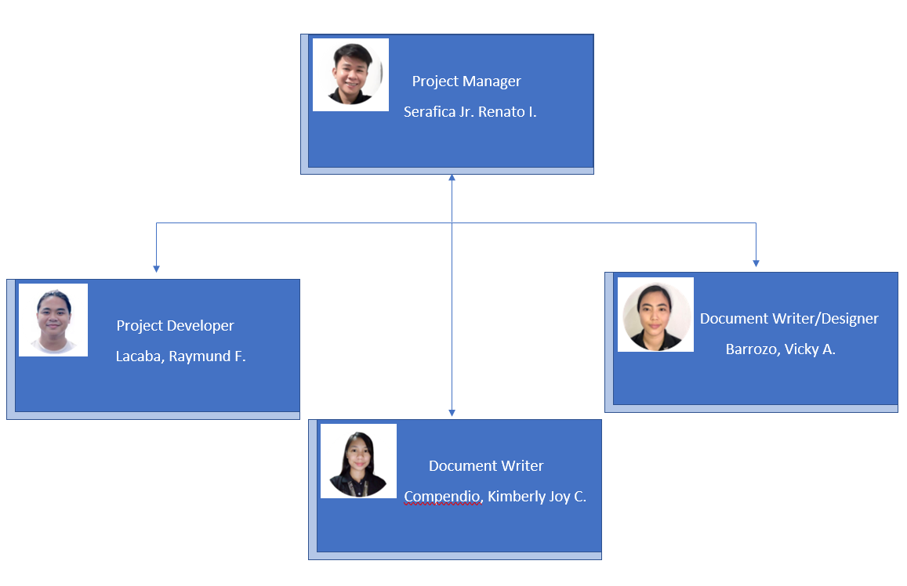

**Serafica, Renato Jr I.**

He is a fourth-year student at the University of Pangasinan, studying Bachelor of Science in Information Technology with a major in Web Development. He is the project manager of this group and he is responsible for making sure that our documents or business plan are complete and in order. He is also quite knowledgeable in the field of development design.

**Barrozo, Vicky A.**

She is also a fourth-year student at the University of Pangasinan, studying Bachelor of Science in Information Technology with a major in Web Development. She is the project designer and document writer of the group. And she is quite good in the field of composing documents for the groups' project.

**Compendio, Kimberly Joy C.**

She is also a fourth-year student at the University of Pangasinan, studying Bachelor of Science in Information Technology with a major in Web Development. She is the document writer of the group project and is good at composing documents.

**Lacaba, Raymund F.**

He is a fourth-year student at the University of Pangasinan, studying Bachelor of Science in Information Technology with a major in Web Development. He is the project developer and designer of the groups project. He is good in the field of developing software programs.

#### **Overall Schedule**

A milestone chart makes it easier for our team members and project or program managers to see and track a project's progress. A milestone chart shows important events that are anticipated to happen at specific times and enables corrective action to be done if the project is running behind schedule, ensuring that efforts effectively stay on course. The majority, if not all, of the paperwork required for the project would have been finalized in Cycle 11, which concludes on September 17 of 2022. After the documentation is complete, the software will start to be produced or developed.

**Milestone Chart**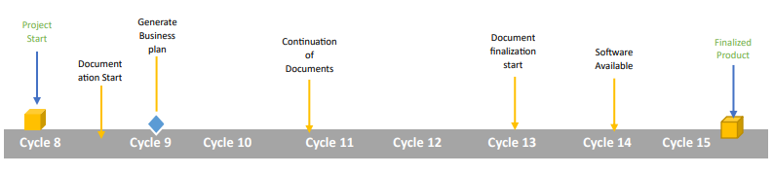

#### **Operations Plan**

The number one most successful way to sell products online is to build a own website. Street Tech company is selling online using its own website. And in order to process online sales transactions there are things to be needed.

**Shopping Carts**

Shopping cart software keeps track of what the user selects to buy from the website before proceeding to the “checkout". An online shopping cart consists of three parts:

**Product Catalogue**

Our system product catalogue is made up of all the information needed to present any product to the customer. Information to be included in the product database generally includes the price, image or other multimedia information, product options or choices.

**Shopping List**

Allows users to track the cell phones they want to purchase. We used a shopping bag image to show what the items shopper has selected to purchase.

**Checkout System**

The checkout system allows our customers to select products by clicking an “add items to cart” button and then enables them to pay for these products.

**Third Party Payment Process**

Since Street Tech is an online shop, there is a third party payment processing service that provides charge transaction fees, including a percentage of the sale plus a flat fee per transaction.

#### **Raising Capital**

**Loans**

A small business loan can help us to do so. In some cases, we may get approved for a significant amount of money so that we can open our doors without worrying about how we’ll pay for initial startup costs. For many business owners starting new ventures, small business loans remain an important stepping stone on the path to success.

**Personal Funds**

Having control over the finances, particularly if it is personal money that is being used, is one of the positives. It leads to an even more determined approach to ensuring the business succeeds if we are the primary funders.

**Crowdfunding**

To raise our capital in business we need to post our business idea on the website. People can then support our campaign by contributing money to help us achieve our goal. On some websites, we’ll set a goal for the amount of money we need, and when we want to reach this goal.

#### **The New Venture Team and Business Ethics**

**Serafica, Renato Jr I.**

He is the Project Manager of the project and in-charge in managing the team's overall duties. He is also assisting our developer to create some ideas to put in our website. To make progress on projects effectively, project manager set goals and time frames for each stage.

**Barrozo, Vicky A.**

She is the document writer of the project andshe is good in the field of designing and writing documents of the projects. Document writers create high-quality documentation and set goals to improve the clarity, conciseness, and accuracy of their work. To make progress on projects effectively, writers set goals and time frames for each stage.

**Compendio, Kimberly Joy C.**

She is the document writer of the project andshe is good in the field of writing documents of the projects. Document writers create high-quality documentation and set goals to improve the clarity, conciseness, and accuracy of their work. To make progress on projects effectively, writers set goals and time frames for each stage.

**Lacaba, Raymund F.**

He is the Project Manager of the project and in-charge in managing the team's overall duties. The part of Raymund in the project is he is one of the developers that specializes in creating programs and functions for the programs. The developers are one who handles the software development of the product, writing codes, and creating functions for the software to do for the end users. The developers are the ones who handle most of the work for the project and they're the ones who understand complicated stuff to implement certain features of the product.

**Business Ethics**

**From The Management of Street Tech**

One of the keys to Street Tech’s success has been the high standard of integrity and professionalism that every member of our staff upholds on a daily basis. As we strive to provide the best service to our clients and the best workplace for our employees as we grow in terms of both our staff size and the variety of clients and locations that we serve, it is critical that we establish clear guidelines for how we should approach any significant issues and decisions that may arise. The associated Code of Business Ethics and Conduct is intended to be the principal source of that counsel.

The major objective of the Code of Business Ethics and Conduct is to inform individuals about the norms and guidelines that should guide our behavior in the workplace with relation to a number of issues.

**CODE OF BUSINESS ETHICS & CONDUCT APPLICABILITY**

Employees should act with integrity, comply with laws, maintain a professional work environment and comply with company policies. They should treat customers, colleagues, and partners ethically at all times.

We won't all agree all the time, but disagreement is no excuse for disrespectful behavior. We will all experience frustration from time to time, but we cannot allow that frustration to turn into personal attacks. An environment where people feel uncomfortable or threatened is not a productive or creative one.

The Business Ethics and Code of Conduct is applicable to all staff members or employees. Any employee who transgresses this code shall be subject to disciplinary action, which may include termination.

**Ethical Conducts:**

**Be considerate**

We all depend on each other to produce the best work we can as a company. Your decisions will affect clients and colleagues, and you should take those consequences into account when making decisions.

**Anti-bribery and corruption**

A company's integrity is essential for maintaining trustworthiness and reputation. Employees should always do their work fairly, honestly, and legally.

**General harassment and sexual harassment**

The company is committed to providing a work environment free of discrimination and unlawful harassment. Actions, words, jokes, or comments based on an individual’s sex, race, ethnicity, age, religion, or any other legally protected characteristic are not tolerated.

**Absence without notice**

Employees who are unable to work due to illness or an accident should notify their supervisor. This allows the company to arrange for coverage of their duties and helps others continue to work in their absence. If an employee does a report for work and the company is not notified of an employee's status for 3 days, it is typically considered a job abandonment.

**Conflict of Interest**

A company's reputation depends on the actions and integrity of its employees. It is essential that they avoid relationships and activities that hurt, or appear to hurt, their ability to make objective and fair decisions.

**Protects Company’s Asset**

Employees should always act to protect company assets, including physical, intellectual, and electronic or digital properties.

**Employees’ obligations to report violations**

Any employee who is aware of any action that is or could be in violation of this Code or any law or regulation that is relevant to the Company's operations must report that activity. Such reports should be made by workers to their immediate managers.

**Investigation of Misconduct**

The Company maintains the right to make any legal inquiries it deems necessary to determine if any person has engaged in behavior that, in the Company's opinion, impedes or adversely affects its operations. Every employee is expected to conduct any investigation into a potential infraction of the law, the Company's rules and procedures, or this Code.

#### **New Age Sources of Income**

**Ways on how to get a source of income in online business**

**Advertisement**

With advertisements, it can help to raise our capital for the business. Aside from that, it will help us to promote the business thru social media platforms. It also allows the business to earn extra revenue. For example, our business is an online mobile shop, we can create a short video for a new release iPhone 14 that shows the feature and specs. Since it’s demand, people will get to know the latest trends and it will boost the brand as well as the sales.

**Merchandise**

Aside from selling phones online, we can use the merchandise as another source of revenue. For example, the new release iPhone 14 versions, we can include accessories on our website like cases, power banks, and more. Not just to sell but to promote our products.

#### 

#### **Feasibility Analysis Template**

**Part 1: Strength of the Business Idea**

| **Areas** | **Low Potential (-1)** | **Moderate (0)** | **High Potential (+1)** |
| --- | --- | --- | --- |
| **Extent to which the idea**   * **Takes the advantage of an environmental trend** * **Solves a problem** * **Addresses an unfilled gap in the market place** |  | **Moderate** |  |
| **Timeliness of entry to market** |  | **Moderate Timely** |  |
| **Extent to which the idea “add value” for it’s buyer or end user** |  | **Medium** |  |
| **Extent to which the customer is satisfied**  **by competing products that are already**  **available** |  | **Moderately**  **Satisfied** |  |
| **Degree to which the idea requires**  **customers to change their basic**  **practices or behaviors** |  | **Moderate** |  |

**Part 2: Industry-Related Issues**

| **Areas** | **Low Potential (-1)** | **Moderate (0)** | **High Potential (+1)** |
| --- | --- | --- | --- |
| **Number of competitors** | **Many** |  |  |
| **Stage of industry life cycle** |  |  | **Growth Phase** |
| **Growth rate of industry** |  |  | **Strong growth** |
| **Importance of industry’s product and/or services to customers** |  | **Would like to have to** |  |
| **Industry operating margins** |  | **Moderate** |  |

**Part 3: Target Market and Customer- Related Issues**

| **Areas** | **Low Potential (-1)** | **Moderate (0)** | **High Potential (+1)** |
| --- | --- | --- | --- |
| **Identification of target market for thee proposed new venture** |  |  | **Identified** |
| **Ability to create “barriers to entry” for potential competitors** |  | **May or may not be able to create** |  |
| **Purchasing power of customers** |  |  | **High** |
| **Ease of making customers aware of the new product or service** |  |  | **High** |
| **Growth potential of target market** |  |  | **High** |

**Part 4: Founder’s- (or Founders’-) Related Issues**

| **Areas** | **Low Potential (-1)** | **Moderate (0)** | **High Potential (+1)** |
| --- | --- | --- | --- |
| **Founder’s or founders’ experience in the industry** | **No experience** |  |  |
| **Founder’s or founders’ skills as they** |  | **Moderate Skills** |  |
| **Extent to which the founders professional and social networks in the relevant industry** |  | **Moderate** |  |
| **Extent to which the proposed new venture meets the founder’s or founders personal goals and aspirations** |  | **Moderate** |  |
| **Likelihood that a team can be put together to launch and grow the new venture** |  | **Moderate Likely** |  |

**Part 5: Financial Issues**

| **Areas** | **Low Potential (-1)** | **Moderate (0)** | **High Potential (+1)** |
| --- | --- | --- | --- |
| **Initial capital investment** |  | **Moderate** |  |
| **Number of revenue drivers (ways in which the company makes money)** |  | **Two to Three** |  |
| **Time to break even** |  | **2-3 Years** |  |
| **Financial performance of similar businesses** |  |  | **Strong** |
| **Ability to fund initial product or service**  **development and/or initial start-up expenses**  **from ærsonal funds or via bootstrapping** |  | **Moderate** |  |

**Overall Potential**

| **Parts** | **Score**  **(-5 to + 5)** | **Overall potential of the businesses Idea Based on Each Part( High, Moderate** | **Suggestions for improving the potential** |
| --- | --- | --- | --- |
| **Part1: Strength of Business Idea** | **0** | **Moderate** | **Gain more knowledge in gaining advantage in the market of our business** |
| **Part 2: Industry-Related Issues** | **+1** | **Moderate** | **Learn how to handle big competitors** |
| **Part 3: Target Market and Customer Related Issues** | **+4** | **High** | **Learn more how to prevent competitor in giving us problems** |
| **Part 4: Founder’s ( or Founders’) Related Issues** | **-1** | **Moderate** | **Gain more experience and skills in running the business** |
| **Part 5: Financial Issues** | **0** | **Moderate** | **Learn more on how to efficiently handle financial issues** |
| **Overall Assessment** | **4** | **Moderate** | **Know how to handle the competitors and be able to identify the new trend** |

### 

### **Conclusion**

We got to the conclusion that our company has a possibility to compete in the current market based on the components of the feasibility analysis template. Due to team inexperience, the execution might not be ideal, but with experience and expertise, the team can grow and be able to do more, effectively optimizing the business for the future.